**OCAKE: ONLINE CAKE ORDERING AND DELIVERY SYSTEM**

An

Application Development Project

Presented to the Faculty of

**Mindoro State University Bongabong Campus**

Masipit, Calapan City

Oriental Mindoro

In Partial Fulfillment

of the Requirements for the Degree

Bachelor of Science in Information Technology

by:

**Arevalo, Cristin C.**

**Ramirez, Jechel C.**

February 2023

**CHAPTER I**

**INTRODUCTION**

**Project Context**

The Online Cake Ordering System and Delivery System are the “mechanical” part of inventory management. Where the systems will easily and efficiently record orders and a receipt. A common tool used by many businesses to manage, find, and keep track of data and information about objects and materials connected to their products is the ordering management system. It is used when filling orders for various types of securities and allows users to follow the progress of each order as it moves through the system. To take and track orders, the majority of business organizations employed paper methods and semi-automated systems like Excel. The system for managing bakeshop orders is the name of the project. This system is focused on ordering, selling, and creating invoices for each customer after ordering and selling the cake, bread, and other pastries. The main principle of a bakeshop ordering management system is primarily motivated by the convenience of shop management. Making a database for the bakeshop to keep track of sales, purchases, and products is the goal of this project. However, the existing approach is ineffective since everything must be recorded on registers, which is challenging to administer. Any report can be checked at any moment. With a sales tracking feature, numerous filtering options, and the ability to generate reports and receipts using a computer, it can aid in reducing time and effort. One of the most creative concepts in this period is the online cake ordering system. It will significantly simplify someone's life. If someone wants to purchase a cake, they only need to visit this system, choose the cake, enter some vital details, and then pay. The cake would be delivered to their door, or anyone might pick it up on their own from the store. Cakes are one of the delicious treats that we see most frequently at special events, and there is always a cake design that goes with the occasion's theme. But a lot of us find it really tedious to visit the bakery and select the ideal cake for loved ones on any important occasion. Even some of us neglect to purchase cakes.

To overcome the issues present in the current manual system, the "Online Cake Ordering and Delivery System" was created. The difficulties our current system has are supported by this program in an effort to eliminate and, in some circumstances, decrease them. Additionally, this system is created to meet the specific requirements of the business to conduct operations efficiently and effectively.

The purpose of the online cake ordering and delivery system is to automate the current manual system with the aid of computerized hardware and comprehensive computer software, meeting their needs so that their important data and information can be stored for a longer period of time with simple access and manipulation of the same. The project essentially outlines how to manage for improved performance and better customer service.

The aforementioned online cake ordering and delivery system can load a fast, safe, trustworthy, and error-free management system. The company can keep computerized records updated without making duplicate inputs. In order to access knowledge, one does not need to be sidetracked by irrelevant information.

**Objectives**

The main purpose of this study is to design and develop an online cake ordering and delivery system for Kelly's Bakeshop. Specifically, this study aims to:

1. Create a system that will enable customers to customize their own cake.
2. Design a website that can monitor the status of a customer’s order
3. Develop an implementation plan for the development of the project.
4. Develop ratings and feedback for the products.
5. Integrate SMS to notify the user when their order has been accepted.
6. Provide a website with all available cake product from which the customer can choose and select;

**Scope and Limitations**

The study covers the online cake ordering and delivery system for Kelly's bakeshop. People are now busy to visit the stores and shop for their party needs like cake to complete their party bash. The business will offer services that enable clients to shop conveniently at anytime, anywhere. The customers can choose from the wide variety of product for the party. The product details, availability of the product is posted in the web page of Ocake: Online Cake Ordering and Delivery System. The customers can purchase right away by online banking debit or money transfer to secure their orders and the customers can also check the status of their orders and delivery by log in on their account and visiting the website.

The system is exclusively for the Cake Ordering and Delivery Service. The administrator is the only authorized person to manipulate the content of this website. If the user is not registered on the system no possible transaction can be done other than viewing the whole website. The cake ordering and delivery service only accepts cake orders and pickups. The website will limit ordering internationally and outside the Municipality of Naujan. With regards to payment, the system accepts cash on delivery and online payment through G-Cash Qr-Code. A bank transfer or any other type of payment is not included. The system also does not have a mobile application and it can only be accessed by desktop, tablet and mobile browsers with internet connection.

**Definition of Terms**

* **Accurate** – It matches a truth or standard in an exact or nearly exact form or performs with complete correctness.
* **Admin** - Someone who has the authority to manage and control the system.
* **Automated** – It is operated automatically by a system or equipment.
* **Customized Cake -** In this study, a customized cake is a cake designed directly by the customer himself through using the application system.
* **Database** - it is used to store the records of bakeshop data to become organized and easy to find.
* **Develop** – To acquire to a more advanced or effective state.
* **Efficient** – Capable of achieving expected outcomes without wasting resources or time.
* **Feedback -** This is the customer's comment regarding the the shop's product and its service. This will help new customers to review the ratings of the product. Also, it will help the shop itself to improve their services.
* **Manual** – It is worked or performed by hand rather than by machine.
* **Online Ordering -** An action where customers purchase online using smart phone or PC. Customers were able to browse online products and make an order.
* **Reliable** – It is someone or something trustworthy.
* **Retrieval** – It refers to the process of recovering something.
* **Service** – It is someone or an organization intended to assist individuals or customers.
* **Transaction** – It is a communication action or activity involving two persons that legally affect or influence one another.
* **Unauthorized Access** – A person gains access to a computer network, system, application software, data, or other resources without permission.
* **User** - Anyone who uses and interacts with the application system.

**CHAPTER II**

**REQUIREMENTS SPECIFICATION**

**Hardware and Software Requirements**

**Hardware Specification**

A laptop was one of the most crucial pieces of hardware used as a foundation for developing. A portable laptop with an Intel Core CPU, 1.60 GHz processor speed, 2.00 GB installed RAM, a 64-bit operating system, and a 64x-based processor was used.

|  |  |  |  |
| --- | --- | --- | --- |
| **QTY** | **UNIT** | **ITEM** | **SPECIFICATIONS** |
| 1 | pc | ASUS Laptop | 15-inch; 12GB RAM; 500 HDD |
| 1 | pc | ACER Laptop | 15-inch; 4GB RAM; 128HDD |

**Table 1. Component’s Specifications**

**Software Specification**

**Table 2. Software Specifications**

|  |  |  |
| --- | --- | --- |
| **Software** | **Specifications** | |
| **Minimum** | **Recommended** |
| Operating System | Windows 7 Ultimate 64-bit | Windows 10 64-bit |
| WAMP Server | WAMP version 64 bits (x64) 3.2.6 | WAMP version 64 bits (x64) 3.2.6 |
| Visual Studio Code | Visual Studio Code version 1.74.2 | Visual Studio Code version 1.74.2 |

Table 2 shows the specifications of the software used for this study. The researchers used the most recent operating system and versions of the mentioned above for optimal use and performance of production.

**Functional Requirements**

Functional requirements pertain to the process and function of the system. This includes how the system should work form its administrator down to the end-users of the website.

**User Interface**

Ocake: Online Cake Ordering and Delivery System Website was built with an aesthetic design by using web designing frameworks to let the users interact freely with the website. The interface and its functions are well-structured to make the user interface and user experience more engaging to the user’s eyes.

**Hardware Interface**

The hardware used in this project meets the specified requirement to successfully run the system. The relation between software and hardware should always be considered for it works side by side to let the developed system run in its optimal state. The website runs in computer and 1 GB Random Access Memory or at least 1 GB RAM. This also runs indifferent brand and version of android smart phone with internet connection.

**Software Interface**

This project provides a software that is user- friendly to the admin of this system. It ensures simplicity and good navigation across the whole website. This project is developed to be used easily by its user. This interface is crucial for the success of the project for it presents the relation and operations between the system itself to its fellow components such as database and operating system. The researchers used Windows 10 operating system, Microsoft Edge as its web browser, Visual Studio Code 1.74.2 as the IDE of the system, WAMP server to create database, Codeigniter 4 PHP Framework to assists researchers by providing the simplest way to use modular methods.

**Security Interface**

The system is protected with password to prevent unauthorized activities that may be done by unauthorized users. This ensures that the system will not be put in jeopardy through attacks from hackers that will cost a lot for the system and its users. The system also enabled all available security modules of Codeigniter 4 PHP Framework.

**Non-Functional Requirements**

**Operational Requirement**

* The app should be compatible with any mobile operating system.

**Performance Requirement**

* Good memory space is required.
* Should be free of errors
* Large amounts of data can be processed quickly.
* Performance should be fast.

**Security Requirement**

* The administrator and the end-user, who have their own username and password, only have the right to open the app.

**Cultural Requirement (if Applicable)**

* The app should be use Tagalog and English language only.

**RELATED LITERATURE AND STUDIES OF CAKE SYSTEM**

This chapter presents the review of related literature that provides the researchers a strong foundation for the study. To confirm the validity of the data acquired, the researchers gathered information from reliable websites. The researchers' knowledge is concentrated on the growth of e-commerce or online business and its benefits for the economy, customers, and businesses.

**Ecommerce**

At present, the digital economy, which focuses on information technology and data as its main components, is currently booming and playing a significant role in helping various countries' economic growth. NV Ivanova (2020) stated that technological development has become a key factor to succeed nowadays but today the global economy is slouching through the recession during the COVID 19 pandemic. According to IBM’S report covid-19 pandemic pushed the industry ahead by around five years.

In one of the articles published by the International Trade Administration (2021) it was stated that the pandemic of COVID-19 has raised demand for eCommerce in the Philippines. Ecommerce is booming because of the growing middle class, rising consumer expenditure, and a young, active, tech-savvy population. (Patricia J. J. A., et al., 2022).

Moreover, after the covid-19, social distancing and staying home further pushed the consumers towards online shopping. COVID-19 pandemic has altered consumers' purchasing behaviors as well as their post-purchase satisfaction levels according to the findings of Andrew M., John N., Kevin M. (2020).

In addition to this, it affected the demand for online food shopping services. During the pandemic, the variety of products offered on the e-commerce platform also rose, indicating that as more customers turn to online platforms, the concentration of sales on niche products may rise. based on the investigation of Hung‐Hao C., Chad D. M. (2021).

The popularity of e-commerce increase after the advent of covid-19 pandemic is 17% and expected to rise further, sectors such as electronics, fashion and accessories, health and pharma and FMCG did particularly well, with an average growth of 133% in sales. The rapid growth and emerging trend of e-commerce led to the emergence of a new group of consumers known as e-consumers. This new group of consumers is increasing in number over the years as online shopping has become a trend and a manifestation of the modern lifestyle. E-commerce is a business strategy that enables organizations and people to buy and sell goods and services online. Today 40% of internet usage was made for an online purchase reported by Komal Sharma (2020).

Mirjana P. B. (2021) stated that it is not too exaggerated to say that electronic commerce has enabled the survival of numerous businesses all over the world, and has supported various personal needs, as well as public functions. Meanwhile, Judit O., et al., (2018) emphasize that there is no denying that electronic commerce has brought many benefits to consumers. E-commerce will make it easy for customers to shop online whenever they want, utilizing secure payment methods. In addition, customers place a high value on the reliability of store websites.

Furthermore, based on the study by Al-Ayed S. (2022), e-commerce and online shopping is the future of global trade, hence the importance of building E-customer loyalty and maintaining it in the electronic markets becomes even more important. Capturing the benefit that customers perceive will be the best strategy for the sustainability of online enterprises in the competitive market. However, according to Minh Ha N., Bui Thanh K. (2019), in the context of increasing human life quality, re-examining the beneficial dimensions of electronic commerce (e-commerce) is a necessity.

**Responsive Website**

Responsive Web Design (RWD) is a method for web development that is used, according to Schade, to create web pages that react to the user's behavior and environment based on screen size, platform, and orientation. RWD is a kind of web design essential for meeting the need for a website. Thus, every new gadget on the market goes through a unique design and development phase (Soegaard, 2018). Currently, most web-based systems are designed to be responsive and dynamically fit the user's screen size. The screen size of the device It is convenient and works with users who have different-sized viewports in terms of responsiveness. The page elements will be reshuffled depending on the user's device screen size. For example, the website will adapt if a user switches from a laptop to an iPad.

The amount of time it takes a user to navigate a website and how that relates to an achievement criterion is another indication of that user's preferences; if the relationship is positive, the user's preferences are at a higher level (Chen, 2018).

Image distortions are unavoidable because every device has a different view resolution, even though a website designed at a fixed resolution ratio may have the proper viewing and usage in the browser with the same resolution ratio. The difference between the code system and how web browsers support it is the cause. Use of the responsive design approach is the coding technique that offers a solution for browser convenience (Oyucu & Polat, 2018).

The interface, as the primary information carrier of websites and software products, carries all user interactive actions. As a result, designers' ability to provide consistent interface display and design across devices is becoming increasingly important (Nogueira, T.D., et al., 2019). The introduction of responsive design (Hung, 2020) as a solution for image and experience consistency across multi-terminal devices has gradually become a widely used design method (Parlakkili, 2021).

Since its inception, responsive design's adaptability and flexibility have provided users with a consistent and sustainable website browsing experience across multiple devices (Walsh, T.A., et al., 2022). Responsive websites have become the industry standard for company presentations, entertainment, shopping, news, education, and so on. Additionally, Clay (2018) has provided suggestions in Creating a short and catchy navigation structure for learning mobile websites, for example finding logical navigation tracks, prioritizing the most crucial links at the top of the navigation menus, observing the font style, the variety of the design, and making sure that the design is compatible with various features on touch screens.

**Cake Ordering System**

In the work, we have directly reviewed several online booking systems including [1] Sweet8Bakery Booking System, [2] Yummyshome Food Ordering and Management System.

According to Nor Farhana, B., Shahreen, K., Rohayanti, H., et al. (2018), the Sweet8Bakery Booking System [1] is accepting bookings of cakes, cupcakes, muffins, and chocolates for entertainment occasions such as weddings, engagements, birthdays, and banquets. The Sweet8Bakery Booking System includes several modules for ease of use. The modules are registration modules, log-in modules, category and product modules, reservation modules, SMS delivery modules, and graph report modules. However, certain adjustments will be suggested in order to strengthen this system even more in the future. Among them, Sweet8Bakery's reservation system needs to provide a booking module that allows customers to book based on their wishes, such as their preferred theme, weight (kg), flavors, and more.

Yummyshome [2] is an online food ordering and management system that specializes in cakes, according to Jayawardena W.L.S.P. (2020). This system is a web application that is mobile-friendly and features login, product, and reservation modules. He asserted that providing exactly what customers need through personalization is the new trend in business. It is crucial to include more customizable features in the system as a result. Allow clients to alter the normal cake's flavors, colors, and icing style, and provide them access to immediate pricing information. It is possible to integrate Google reviews and ratings on the products to make it easier for buyers to decide what to buy. It is possible to incorporate an online payment system that accepts credit cards, debit cards, and third-party payment methods.

The internet is well-known for its one-of-a-kind tool for global communication. One of the ways that the internet is useful to humans is the current trend of online shopping. Customers can select the products and services they want by visiting a specific website. This type of shopping trend benefits both the customers and the sellers. Clients will save time, money, and effort by not having to visit the store to physically inspect the items. Clients can view the available sizes, colors, prices, discounts, and availability of the items they require by browsing the seller's website. To fully understand the work flow of a eccommerce system, a thorough review on equivalent systems has been done as a guideline for development of the proposed system and overcoming the weaknesses which present in the existing system.

You could believe that starting a business in baking is the most difficult part. Sure, it requires a lot of work, and you could have a few sleepless nights and feel a little anxious. However, once your bakery is operational, surviving the competition will become your first priority. Additionally, you want to become a destination for those looking for delectable pastries, rather than just trying to stay afloat. In the bread industry, you want to turn a profit as an entrepreneur. You will need to manage your finances, reports, and inventories carefully in order to accomplish this, but there is one aspect of the business that is sometimes overlooked: marketing. You should develop a solid marketing and sales strategy for your bakery regardless of the products your company specializes in, such as croissants, donuts, buns, bread, nutritious gluten-free pastries, mini-pastries, and so on. Otherwise, expanding the consumer base, boosting bakery sales, and raising brand recognition would be difficult. It's critical to have a clear understanding of your target market before opening your bakery, as well as how you intend to promote to them. This enables you to select a nation's restaurant. News: 43% more respondents had visited a bakery since their previous study in 2008, which was conducted in 2008. Of those, 72% claimed to frequent bakeries at least once a month. According to the study, the primary trends in bread, bakery, and pastry innovation are related to health, enjoyment, and convenience. This article examines how product innovation in bread and related items is influenced by gastronomic trends. Leading chefs and new cuisine see bread and bakeries as an essential component of their innovative offerings rather than just a side dish to the meals they serve in their restaurants. The drivers of innovation and key components in this craft will be demonstrated through a case study of many top small innovative enterprises in Spain. We'll examine how these creative patterns have affected the bread and dessert industries. We'll also examine how these creative patterns have affected the bread and dessert industries.

Merriam-Webster stated, "Cake is a delicious baked food formed from a dough or thick batter that often contains flour, sugar, eggs, and a rising agent like baking powder." In Indonesia, "kue basah," or moist cake, and cookies are the two main categories for cakes, depending on their water content. Because its ingredients, such as wheat, sugar, coconut milk or water, eggs, and salt, are susceptible to spoilage, moist cake typically has a soft texture and is short-lived or perishable. Compared to a moist cake, cookies often have a slightly firmer and more durable texture. Additionally, the methods of cooking differ, with pastries and cookies typically being baked, whereas moist cakes are typically steamed and baked.

The secret to these cakes, according to the Philippine Daily Inquirer (2018), is a type of frosting called buttercream, as well as a ton of creativity and skill on the part of Valerie Valeriano and Christina Ong. The two-person team behind it is called Queen of Hearts Couture Cakes, and they are situated in London. They educate themselves on how to achieve things and base their new designs on requests or trends. Since then, they have produced designs inspired by stained glass, macramé, art, and fashion. They searched online for instructions because they were on a tight budget and discovered ones on baking and decorating. They learned how to decorate cupcakes with buttercream, and their first design was a bouquet of sunflower-shaped cupcakes with an Oreo biscuit in the middle. Since no one else was creating buttercream decorations, the moms' responses were so encouraging and positive that they started to think about going into the baking business. Then they gave it their all, but it took some time for them to be noticed. Because Valeri and Christina are the kind of individuals that offer everything they have when they embark on a project, in 2011 they started a new business they named Queen of Hearts Couture Cakes.

**Synthesis of the Study**

Examining and analyzing numerous online systems that are relevant to the researcher's development is one of the goals of literature and study. To aid in the building of a dependable and effective system, other systems are used in the project. These researchers investigate ways to use in an advanced system. Numerous positive aspects of the reviewed online system are present in the built system.

The other online ordering system's or ecommerce's main objective is to enable online ordering by customers. Other helpful elements are offered to customers by various systems in addition to online ordering and delivery. The Ocake: Online Cake Ordering and Delivery System is expected to produce an abundance of useful data as a result. New features will be added to the created system after researching several online platforms.

Customers will be able to customize their own cake design using the system-based, which will be able to display all available cake products. Furthermore, it will be able to track the status of a customer order and notify the user via SMS when their order has been accepted. The built system will not only include the existing capabilities of the online ordering system, but will also add new ones to improve its functionality.

**Chapter III**

**Design and Development Methodologies**

**System Design**

**Database Design**

**Architectural Diagram/ Block Diagram**

Figure 4 shows the system architecture of the Ocake: Online Cake Ordering and Delivery System. The user should register in order to access all the features and functions of the Online Cake Ordering and Delivery Website.

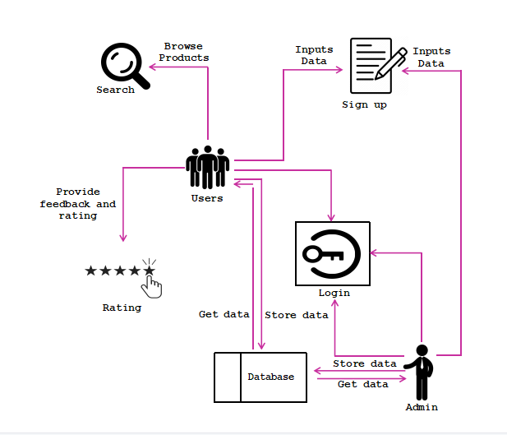This part of research display the detailed structure about the flow of the system function, and the execution of tasks to progress successfully.

**Figure 1. Architectural Diagram**

**DFD Level 0**

Researchers looked at the existing system's manual processes and created a data flow diagram to evaluate and compare them. An E-COMMERCE WEBSITE SYSTEM data flow diagram is used to illustrate the movement of information throughout the system. E-commerce data flow diagrams show how the information will be processed throughout the project. In this case, the DFD Levels serve as illustrations. The data flow diagram for an online store is defined by the input, processing, and output stages. A data flow diagram will reveal the pathways taken by information as it travels from one process to another within an application.

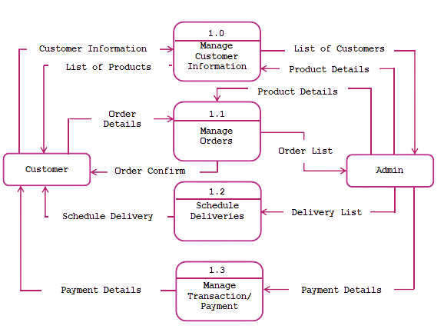

**Figure 2. Data Flow Diagram**

**UML Use-case Diagram**

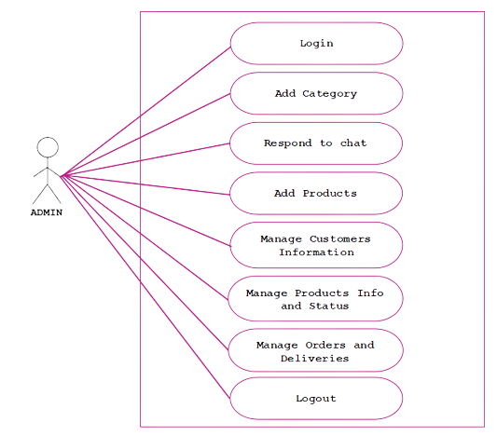Figure 3 below shows the tasks of the administrator where the whole management of the system takes place.

**Figure 3. Use Case of the Administrator**

Figure 4 below shows the features that a user can do in the Ocake: Online Cake Ordering and Delivery System Website.

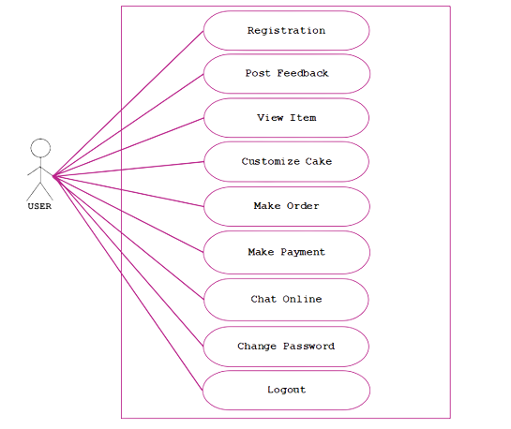

**Figure 4. Use Case of the User**

**Sample Mock-up**

**Development Method**

This chapter will discuss about the preparation of the Ocake: Online Cake Ordering and Delivery System. The research methodology and method were explained to further justify the data gathered along with the system’s structural models to expand the presentation and understanding of the development of the website.

**Development Method**

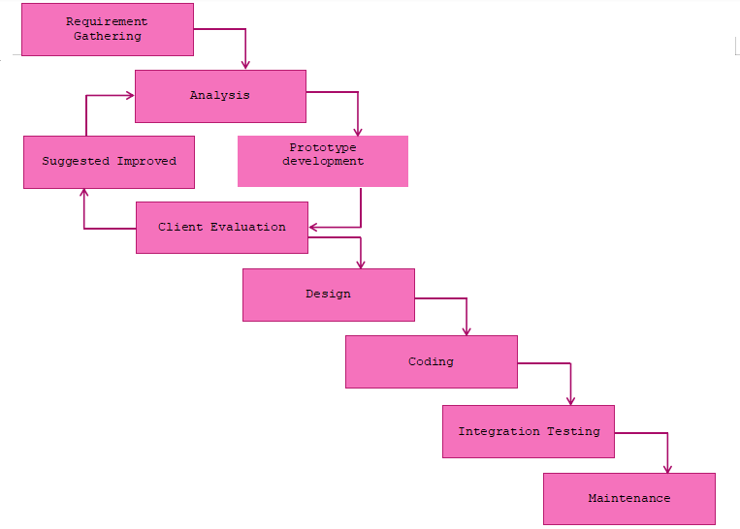

**Figure 5. Evolutionary Prototyping Model**

1. **Requirement Gathering**

The researchers gathered information to meet the user’s satisfaction on developing the website through a series of interviews with the client and some potential users. They first prepared a request letter and sent it to the client. Upon approval, the proponents and the client discussed the requirements such as flow of their business, their operation time, minimum count of customers per day, available delivery and payment method and common problems they encountered.

1. **Analysis**

The researchers looked at what needed to be done in the period allotted and discovered appropriate functionalities and tools for creating the Ocake: Online Cake Ordering and Delivery System's website such as the menu where customers can choose from, an admin module for the update of transactions, as well as the color theme needed for the system.

1. **Prototype Development**

The researchers made a prototype for the website development to make the functionality more reliable and effective and to improve the things that should be done accordingly to user satisfaction, so that the clients could visualize and become familiar with the system flows. The researchers also identified what are the other functionalities to be added and should be applied to the website.

1. **Suggested Improved**

In this phase, the researchers will work on the recommendations of the client and instructors on the documentation and system.

1. **Client Evaluation**

In this phase, the researchers will give a visit to the client and present the project and its features for them to evaluate it according to their satisfaction and needs for every transaction while using the system. This includes the design of the website such as the theme of the website and the logo used.

1. **Design**

The researchers will finalize the design suggested by the client and planned for a better user interface for the website development of the Ocake: Online Cake Ordering and Delivery System.

1. **Coding**

After making the designs for the system, the researchers will proceed to coding. This is where they will implement coding of front-end using HTML, JavaScript as well as bootstraps and back-end using PHP and (using CodeIgniter 4 Framework) to build and create the major parts and functionalities of the website. They will first built an admin module for the data management, followed by the user module to create transactions. On the other hand, the proponents will use MySQL database to store information needed by the website.

1. **Integration Testing**

At this stage, the researchers will integrate the website and test its features and functions. It will be uploaded online to test its overall functionality. The researchers chose Hostinger for web hosting and deployed the website to the World Wide Web. The researcher once again, will show how to use the website by presenting it to the client and other staff. After that, it will be deployed to Kelly's Bakeshop by allowing the client to manage the admin module

1. **Maintenance**

The last stage is maintenance. In this phase, the researchers will maintain and support the function and performance of the system. During the implementation period, the researchers will provide technical support. These include fixing errors encountered by the system during implementation such as unresponsive navigation, database error and unfit logo size to ensure that the system is working properly and operating continuously.